Traffic Simulation and Visualization

Project Two Proposal

Computer Simulation

Ziyi Zhang

Dear Professor Peskin,

I am writing this letter to demonstrate my project plan in your course Computer Simulation. The project will simulate the traffic of an arbitrary graph and visualize the result with MATLAB movies. Any directed graph can be used as the input and the simulation will be fully automated.

The project is consisted of the following two parts:

* With any input graph, simulate for every tick the generation of new cars, the dynamic calculation of routes, update the velocity of cars and the movement of cars. Some corner cases like crossroads should be carefully handled.
* The visualization will use the data generated by the simulation program and plot the trajectory of cars on-the-fly.

The highlight of this project is that it supports arbitrary input. We can use it to explore the effect of an elevated line, the layout of a megacity or the influence of rush hours. I will try my best to build a stable system and pick a topic to play with.

Yours sincerely,

Ziyi Zhang – zz2463

Supplementary Material

As always, I have done some preliminary work before writing this proposal. I managed to write a program to automatically plot the map based on user input.

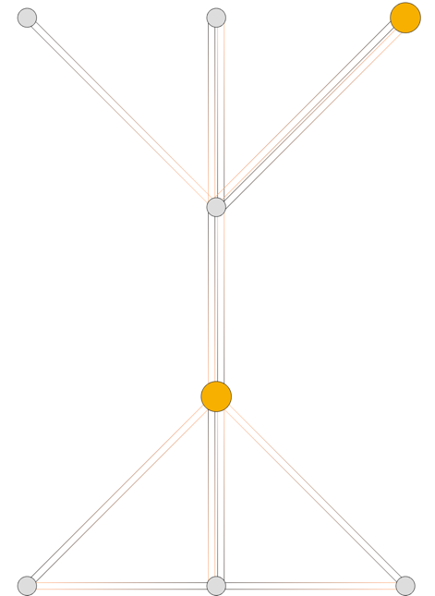

But the simulation program is very hard to get right. There are a lot of fatal bugs in my code now. I will try to fix them to the best of my ability.

Another issue is dynamic path finding. I have discussed with Prof. Peskin via emails, and he thinks it can be done. I will do some experiments about this.